sudo apt-get install scrot

scrot

Delay 10 seconds for screenshot

scrot -d 10

Select **File Manager**, the screenshot is in the upper left corner of the screen as an icon like a filling cabinet.

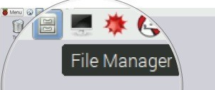

Select the folder on the left titled **Pi, your user.**

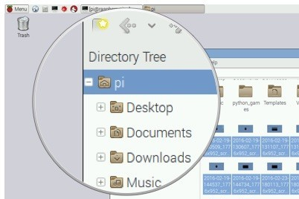

Scroll down to the bottom of the folder's contents to identify the screenshots.

Screenshots will be organized chronologically by date and time in the

/home/pi folder.

Otra alternative, guarda la imagen en un archivo

**scrot /home/pi/pictures/name.png**

Para manipular imagenes hay varias alternativas

Tuxpaint

sudo apt-get install pinta

sudo apt install kolourpaint

sudo apt-get install gimp